MENTORNESS ARTICLE – TASK 1

MIP-ML-09 Batch

**Streamlining Machine Learning Workflows**

**A Guide to Building End-to-End ML Pipelines**

By Sandesh Pednekar



**Introduction:**

In the realm of Machine Learning (ML), the journey from raw data to deployed models involves a series of intricate steps.

Machine Learning Pipelines offer a systematic approach to orchestrate these processes seamlessly, encompassing data preprocessing, model training, evaluation, and deployment. In this article, we delve into the concept of ML pipelines, exploring their significance in streamlining workflows and facilitating efficient model development and deployment.

Through practical insights and illustrative examples, we unravel the key components and best practices for constructing robust end-to-end ML pipelines.

**Understanding Machine Learning Pipelines:**

Machine Learning Pipelines serve as a framework for automating and standardizing the end-to-end process of building ML models. These pipelines encapsulate data preprocessing tasks, feature engineering, model training, evaluation, and deployment into a cohesive workflow. Let's visualize the components of an ML pipeline:

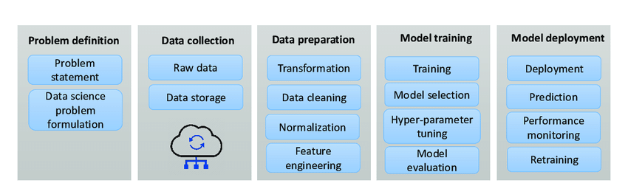

*Fig. 1: Diagram showcasing the sequential flow of tasks within an ML pipeline, from data ingestion to model deployment.*

**Data Preprocessing: The Foundation of ML Pipelines:**

Data preprocessing lays the groundwork for model development by transforming raw data into a format suitable for training ML algorithms. This stage involves tasks such as data cleaning, feature scaling, and handling missing values. Let's delve into the data preprocessing stage:

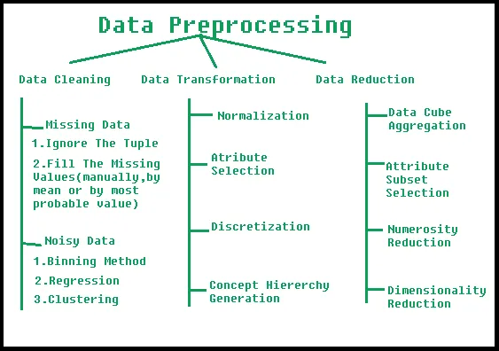

*Fig. 2: Various Types of Pre-Processing*

**Model Training and Evaluation:**

Once data preprocessing is complete, the next step in the ML pipeline involves selecting appropriate algorithms, training models, and evaluating their performance. This stage entails techniques such as cross-validation, hyperparameter tuning, and model selection. Let's visualize the model training and evaluation process:

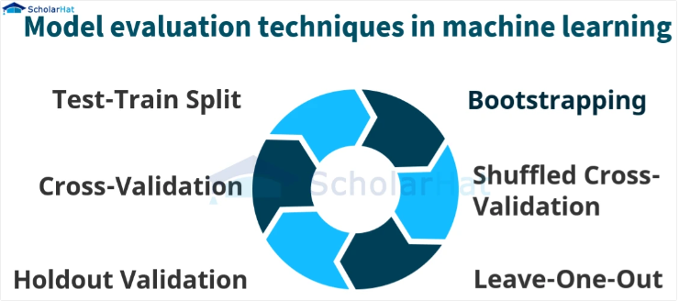

Here are brief explanations for each of the mentioned concepts:

1. **Train-Test-Split:**

A fundamental technique in ML, it involves dividing the dataset into two subsets: one for training the model and another for evaluating its performance. This ensures that the model's effectiveness can be assessed on unseen data.

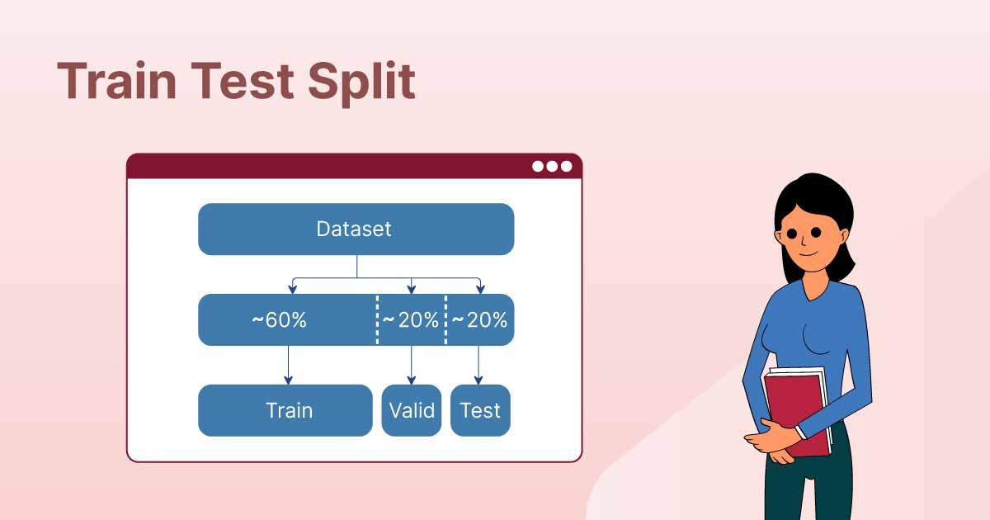

1. **Cross Validation:**

This method involves partitioning the dataset into k subsets, using k-1 subsets for training and the remaining subset for validation. This process is repeated k times, with each subset used as the validation set once, resulting in robust model evaluation.

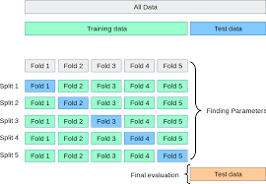

1. **Holdout Validation:**

In this approach, a portion of the dataset is set aside as a validation set, which is used to assess the model's performance after training. Unlike cross-validation, holdout validation involves a single split of the data and is commonly used for larger datasets.

1. **Bootstrapping:**

Bootstrapping is a statistical technique that's used to draw an inference about the parameters of population based on the samples drawn from it with replacement and averaging these results out. In the event of sampling with replacement, samples are drawn one after another, and once one sample is drawn from the population, the population is replenished with the sampled data:

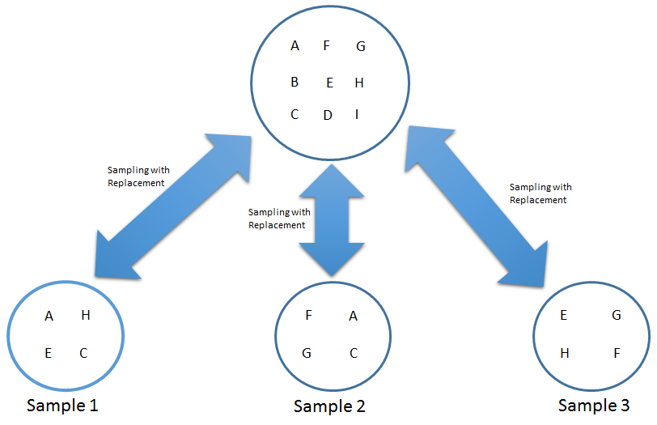

1. **Shuffled Cross Validation:**

Similar to traditional cross-validation, but with the additional step of shuffling the dataset before partitioning. This helps ensure that each fold contains a representative sample of the data, reducing the risk of bias in model evaluation.

1. **Leave-One-Out:**

A specialized form of cross-validation where each data point is used as the validation set once, with the rest of the data used for training. This approach is particularly useful for small datasets but can be computationally expensive for larger ones.

**Deployment: Bridging the Gap between Prototypes and Production:**

The ultimate goal of ML pipelines is to deploy trained models into production environments, where they can generate actionable insights and drive business value. Deployment involves containerization, scalability, and integration with existing systems.

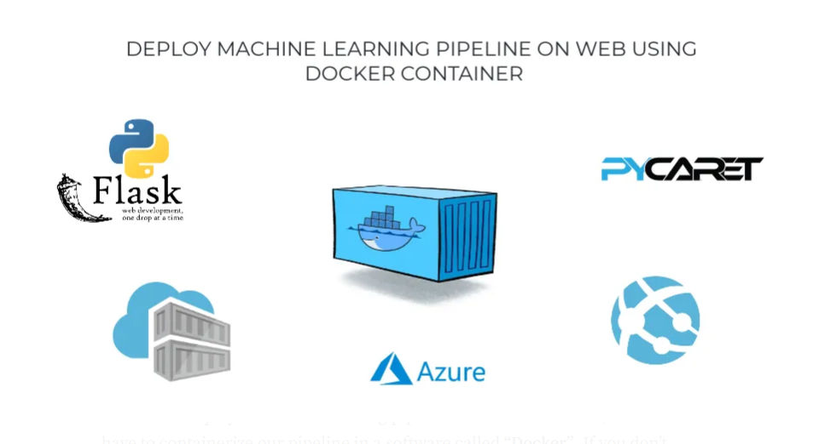

here's a concise example:

"In deploying a sentiment analysis model for customer feedback, the data science team encapsulates the trained model into a Docker container along with necessary dependencies. They then push the containerized model to a Docker registry. Using Kubernetes, they define a deployment manifest specifying the desired state. Kubernetes orchestrates the deployment of multiple replicas of the container across nodes, ensuring high availability. As feedback data flows in, Kubernetes automatically scales the replicas based on demand, offering seamless sentiment analysis for improved customer insights."

**Conclusion:**

Machine Learning Pipelines offer a structured approach to navigating the complexities of model development and deployment.

By automating repetitive tasks, standardizing workflows, and facilitating collaboration between data scientists, engineers, and stakeholders, ML pipelines streamline the end-to-end process of building and deploying ML models.

As organizations embrace the power of data-driven decision-making, the adoption of ML pipelines becomes paramount for realizing the full potential of Machine Learning in driving innovation and competitiveness.

Through continuous refinement and iteration, ML pipelines pave the way for scalable, reliable, and efficient deployment of ML solutions across diverse domains and industries.